Create a shell script to print the HTTP error code of guvi.in & print, the success/failure message based on the error code response

If the provided URL is correct, it will return a 200 HTTP status code. In this case, the message within the 'if' block will be shown. For any other status code, the message in the 'else' block will be displayed.

**Example 1 with proper URL**



**Example 2 with incorrect URL**

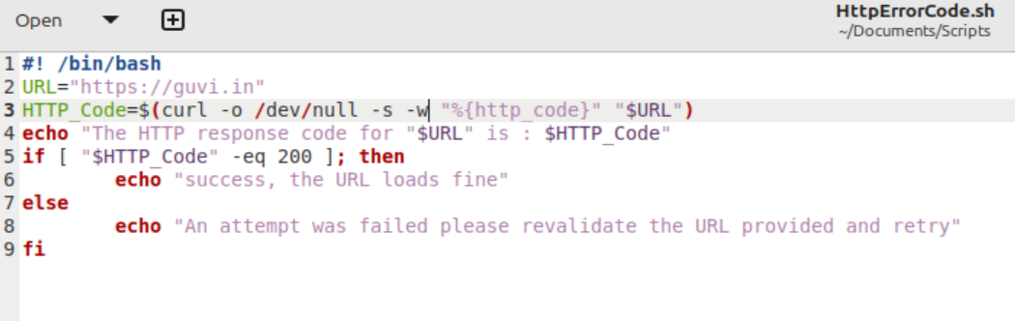



Given a file, replace all occurrence of the word "give" with "learning" from 5th line till the end in only those lines that contain the word "welcome"

**Note**: Line 8 satisfies the requirements, so when the script is executed, only that line will be modified. While line 6 includes both the words 'give' and 'Welcome,' the uppercase 'G' in 'give' disqualifies it from meeting the criteria, meaning it will remain unchanged. Additionally, although line 3 contains both 'give' and 'Welcome,' the script is designed to alter lines only after line 5 as per requirment, so this line will also not be modified.A screenshot of a chat
